Is Areg deficiency associated with reduced Ghr expression?

Question: Why think Areg might regulate/be associated with the expression of Ghr?
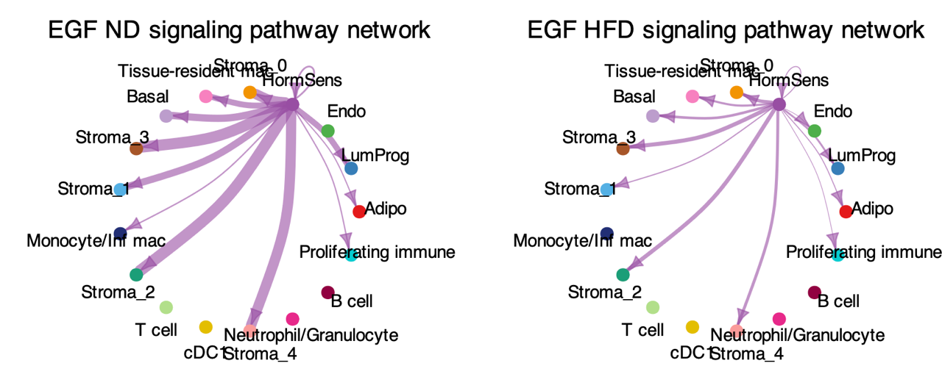
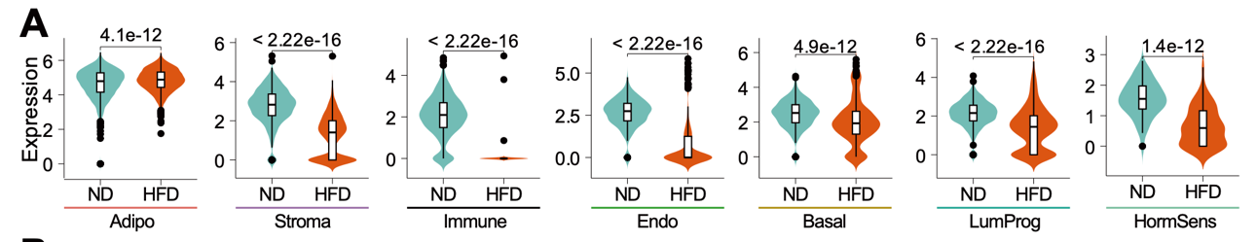

Background:
- No prior report of this regulation.
- Reported: E affects Ghr expression in mammary gland.
- Hypothesis: This effect is partially mediated by Areg.

Experimental plan:

1. Manipulate Areg
- Approaches (X Areg):
  - RNAi
  - CRISPR-dCas13 targeting RNA
  - CRISPRi targeting promoter/enhancer
  - CRISPR knockout
  - Adam17 inhibition with drug
- Verification (Ensure Areg is X):
  - qPCR
  - Immunostaining

2. Manipulate Egfr
- Approach (X Egfr):
  - Egfr antibody
- Verification (Ensure Egfr is X):
  - Western blot for phosphorylated EGFR (p-EGFR)
  - Immunostaining for total EGFR

3. Observe Ghr Expression
- mRNA level using: qPCR
- Protein level using: Western blot

4. Interpret Results

If Ghr is down:
- GH stimulation → measure pSTAT5 response.
- Rescue experiment: add exogenous Areg.
- X Egfr: evaluate significance — if the suppression remains, no further Ghr analysis is needed; focus on the physiological effects under HFD.

If Ghr is not down:
- Conclude that Ghr downregulation is not mediated by Areg deficiency.
- Future direction: check if Ghr expression recovers after switching to a normal diet (ND).
  - If not, consider drug-based interventions.

